WEEK 1 ASSIGNMENT

**CIT400A** INTRODUCTION TO COMPUTER TO SKILL

**FIVE KEY OPERATION OF COMPUTER BASICS**

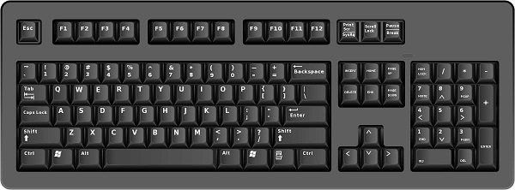

Monitor

MOUSE

CPU

Printer

Keyboard

POWER BUTTON

Power Button

Keyboard

PRINTER

HA

DESIGNED BY MISS LEBONA

COMPUTER CASE

MOUSE

Computer Basics-5key operations.

1. **Powering on**

**Description**: Press the power button to start the computer. Wait for the system to load the desktop screen

**Hardware**: Power button to start/CPU

**Software**: Operating System (e.g. windows)

2. **Typing a Document**

**Description**: Use word processor to type letters, assignments, or notes.

**Hardware**: Keyboard

**Software**: Microsoft word

**3. Saving File**

**Description:** After typing, save work to a folder or device.

**Hardware :** Mouse

**Software :** windows file Explorer

**4. Printing a document**

**Description:** send the document to the printer to get a paper copy.

**Hardware:** Printer

**Software :** Print feature in MS word

**5. Shutting Down**

**Description:** Close all files, then click “Shut Down” to turn off then computer safely.

**Hardware: Power** button

**Software :** Windows start menu

Explanation of how computer operation support a real world task (e. g, creating a school report)

Basic computer operations are essential for completing real world tasks like creating a school report .First, powering on the computer allows the user to access programs needed to begin work. Once the system loads, a word processing software such as Microsoft word is used to type the content of the report. The keyboard is the main hardware used to input text and headings. As the report progresses, the user saves the file regularly to prevent data loss. This uses both the mouse (hardware) and Windows file Explorer (software).Once the report is complete, the user can print a hard copy using a connected printer. This step transforms digital work into a physical document for submission. Lastly, shutting down the computer properly ensures no file damaged. These operations work together to help students’ complete academic tasks efficiently, safely, and professionally.